Versions:

|  |  |  |  |
| --- | --- | --- | --- |
| Date | Versiune | Autor | Comentarii |
| 12.01.2020 | 2 | Victor Padurean | Final analysis and design |

Analisys&Design for BeaMercat

Content:

1. **General Presentation**
2. **Theoretical Fundamentals**
3. **IT Technology**
4. **Functionalities**
5. **Actors and related access rights**
6. **Use Case Diagrams**
7. **System Architecture**
8. **Design**

1. **Operation Mode**
2. **Portability**

**1. General Presentation**

.

BeaMercat is an e-commerce website having a diversity of products available, organized by categories and providers. Each customer has a shopping cart in which they can stack the products they are interested in and can place an order containing each product present in the shopping cart. It will also have an admin type of user that can manage categories, providers, products, orders and users.

1. **Theoretical Fundamentals**

The project will be carried out using an iterative aproach, that is, all the basic components will be created and added during the first iteration. If all goes well, the next itteration will bring new additions to the project. For example, after the first iteration, the administrator and the customer should be able to do their jobs accordingly, after the second itteration, a new actor can be introduced, a courier, which will receive orders, after the third, a product scoring system may be added and so forth.

1. **IT Technology**

The technologies that will be used are Spring Boot, for creating the Web Server.

JavaServer Pages can be used for creating the presenetation layer, by integrating HTML with CSS and Java or JavaScript code.

MongoDB is used for persistence, keeping data as BSON documents.

1. **Functionalities**

Each user has an account with their necessary details and the access to the website pages is done via an authentication process.

The site can be easily administrated by an admin type user which can see all the other users, products, categories and providers.

Each customer will have a personal shopping cart in which they can save products they wish to buy. The checkout process is simple, one being able to select delivery to their personal address or to a newly added address.

The courier can see the orders they must deliver.

1. **Actors and related access rights**

The actors are administrator, courier and customer. If a user has no account, they may access only the welcome page and register page.

The customer has access to their own account details, to all available products, filtered by category or provider, to their placed orders and to their shopping cart details.

The administrator has access to all the pages, including category, products, users and provider creation, update, deletion and listing. They can also see all the orders and create or update them according to the customers’ requests.

The courier can only update their details and see the orders they have to deliver. When an order is complete, they may update the status of the order.

1. **Use Case Diagrams**

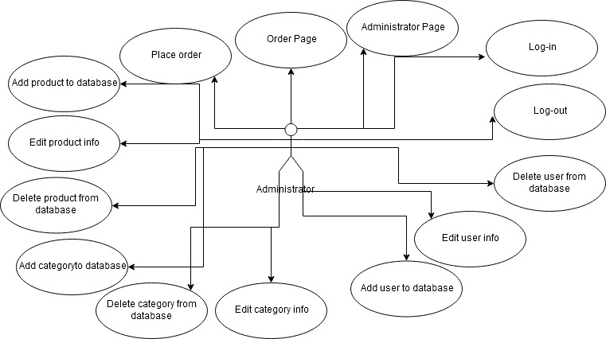

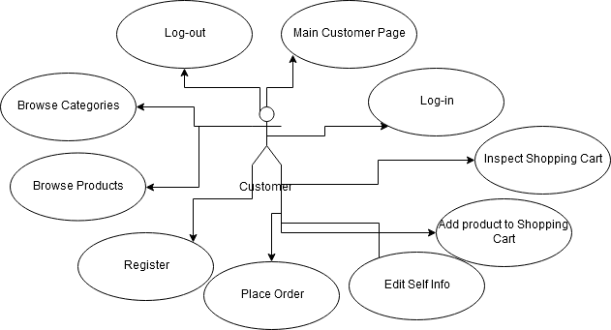

1. **System Architecture**

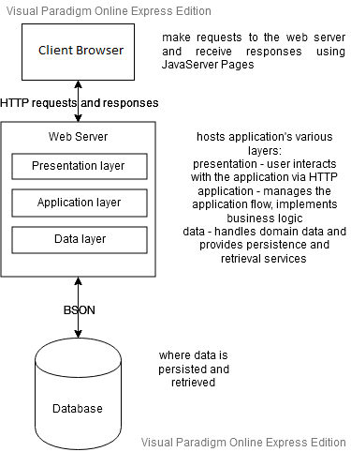

1. **Design**
   1. Database Diagram

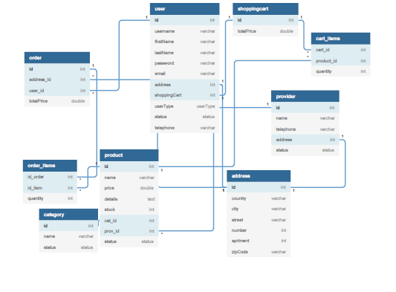

* 1. Activity Diagram

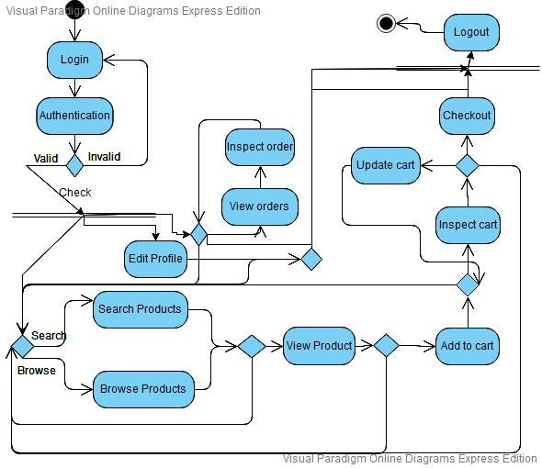

* 1. Class Diagram

* 1. Communication Diagram

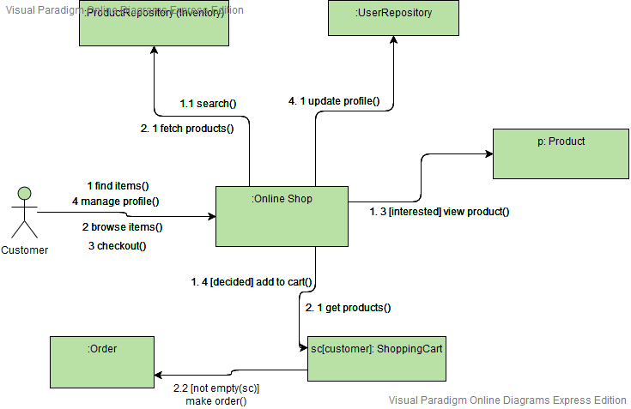

* 1. Component Diagram

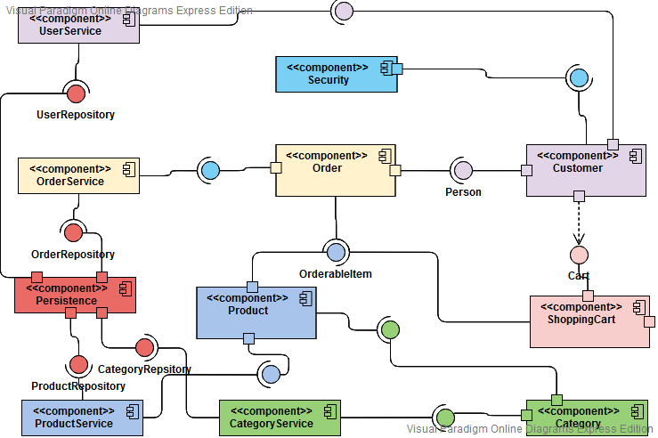

* 1. Deployment Diagram

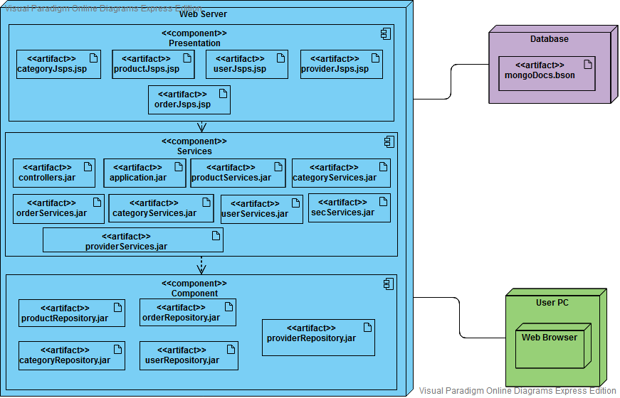

* 1. Flowchart

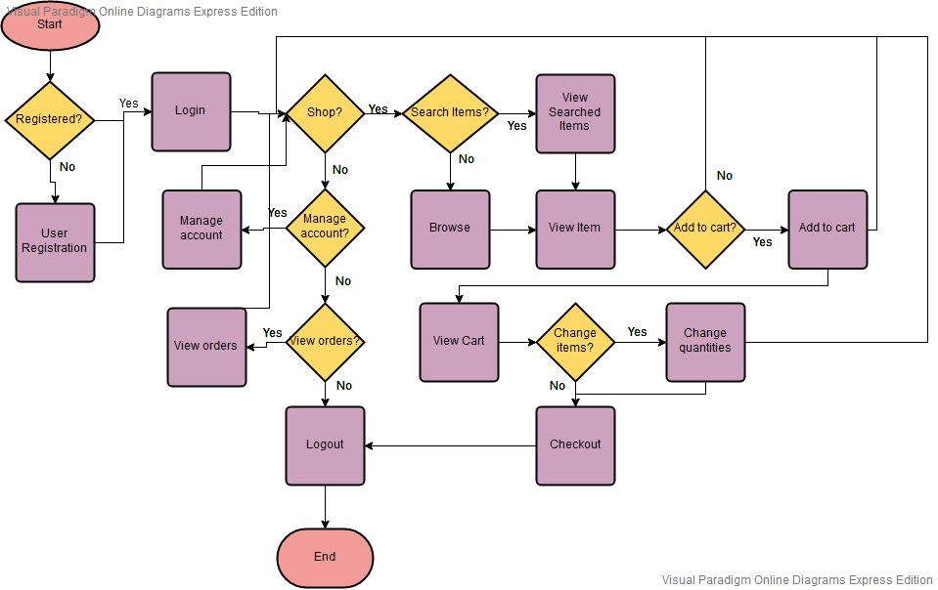

* 1. Interaction diagram

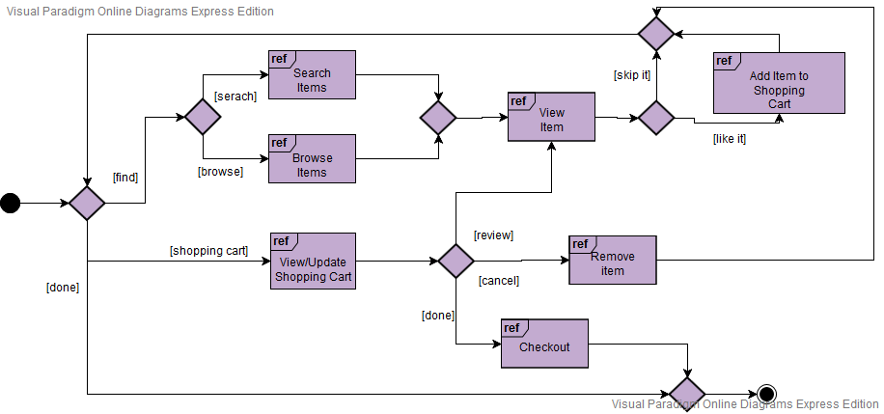

* 1. A picture containing screenshot

     Description automatically generatedObject Diagram
  2. Package Diagram

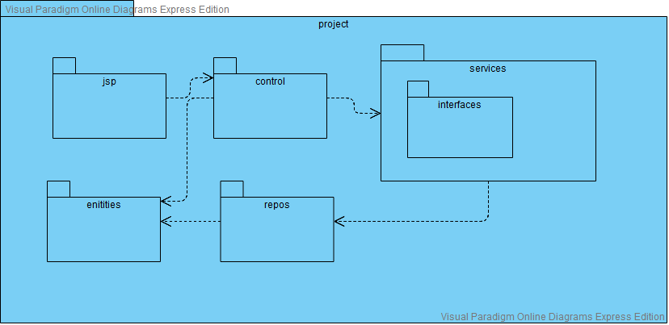

* 1. Sequence Diagram

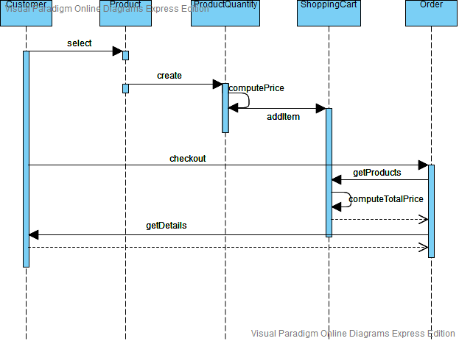

* 1. State Diagram

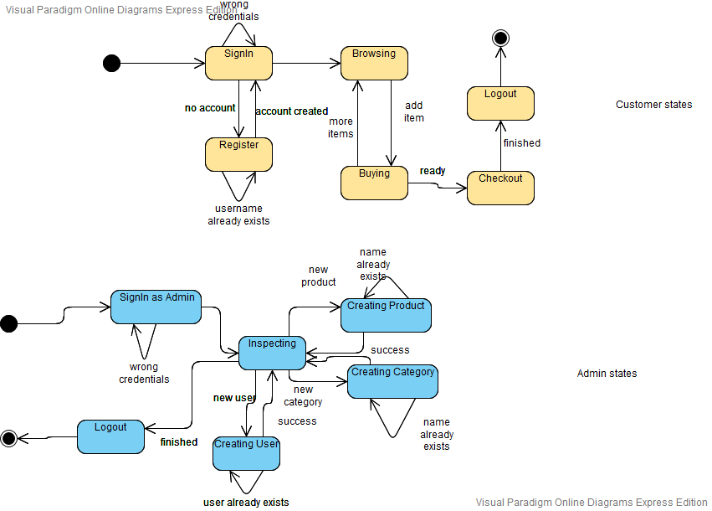

1. **Operation Mode**
   1. Welcome Screen

The user may register (only as a customer) or login if they already have an account.

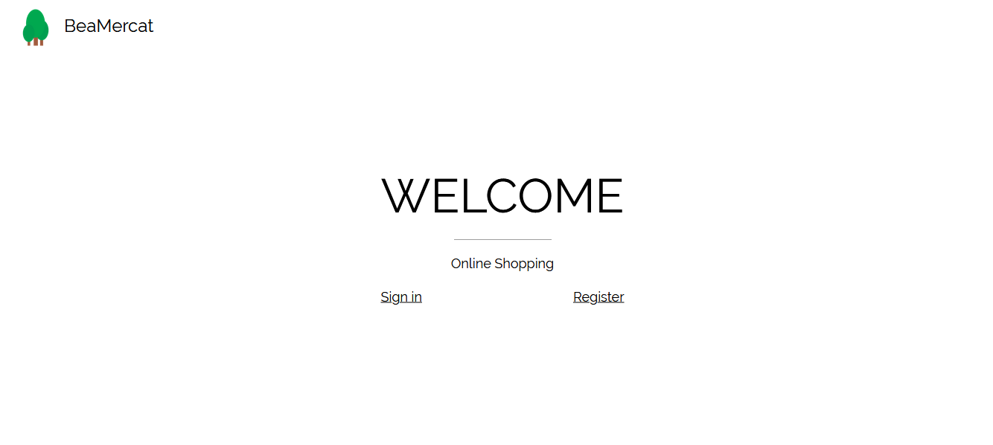

* 1. Create user

The user may create an account by submiting their details.

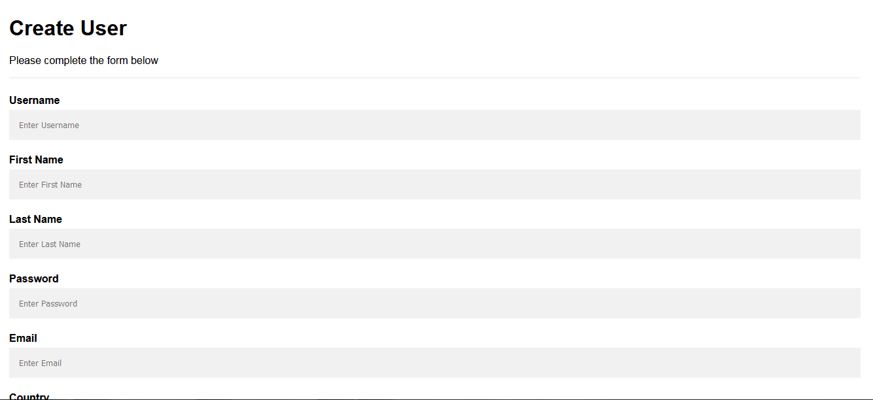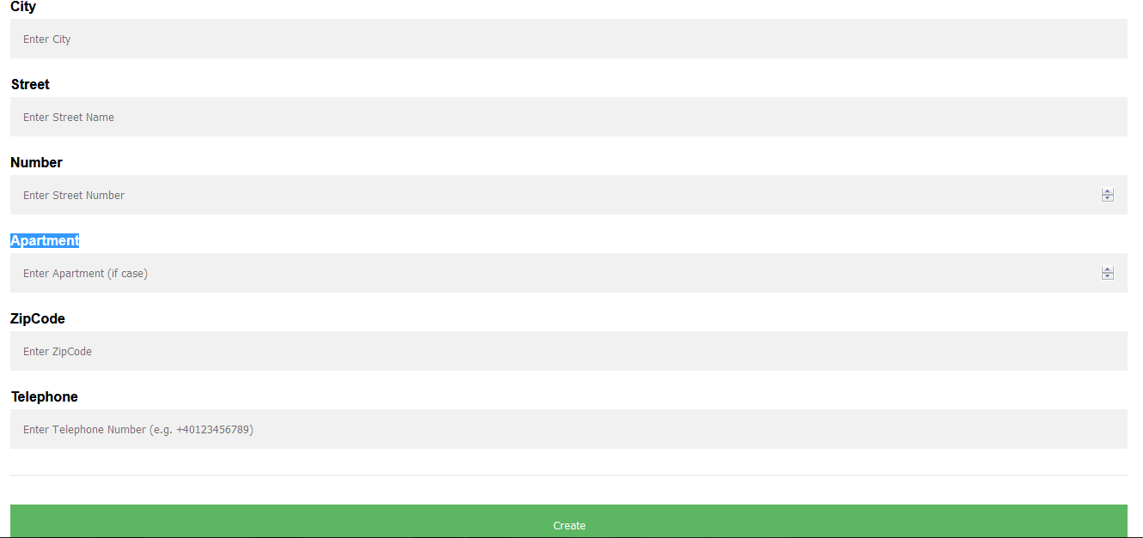

* 1. Main page

It presents the user some offers and shows the menu bar, making the site navigable.

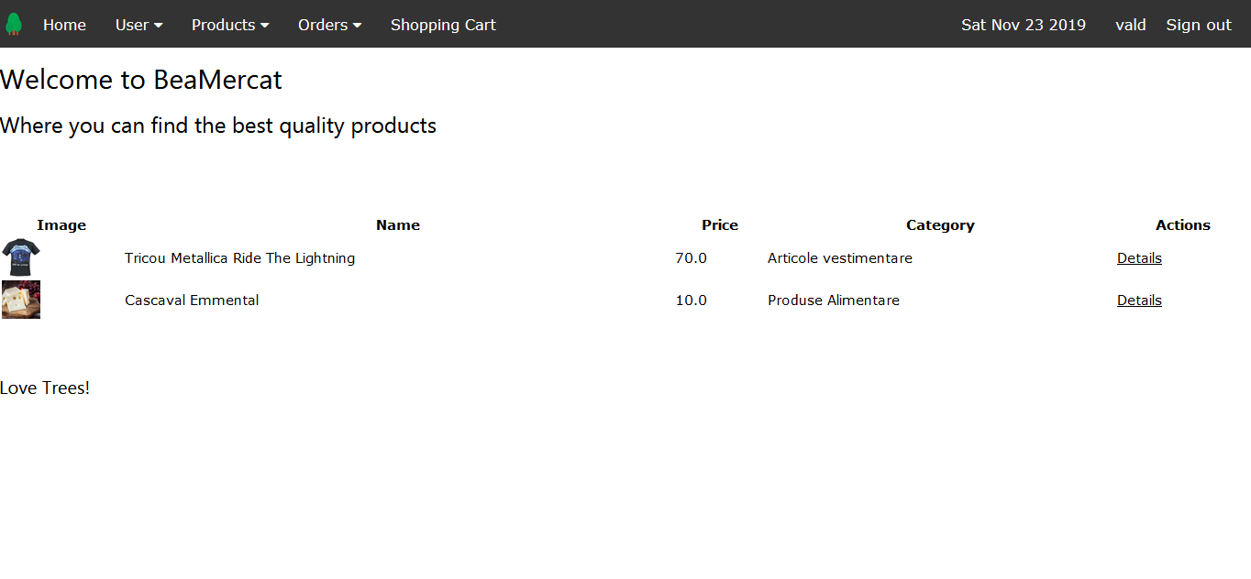

* 1. Create product

An admin type user may add new products to the database by using this page.

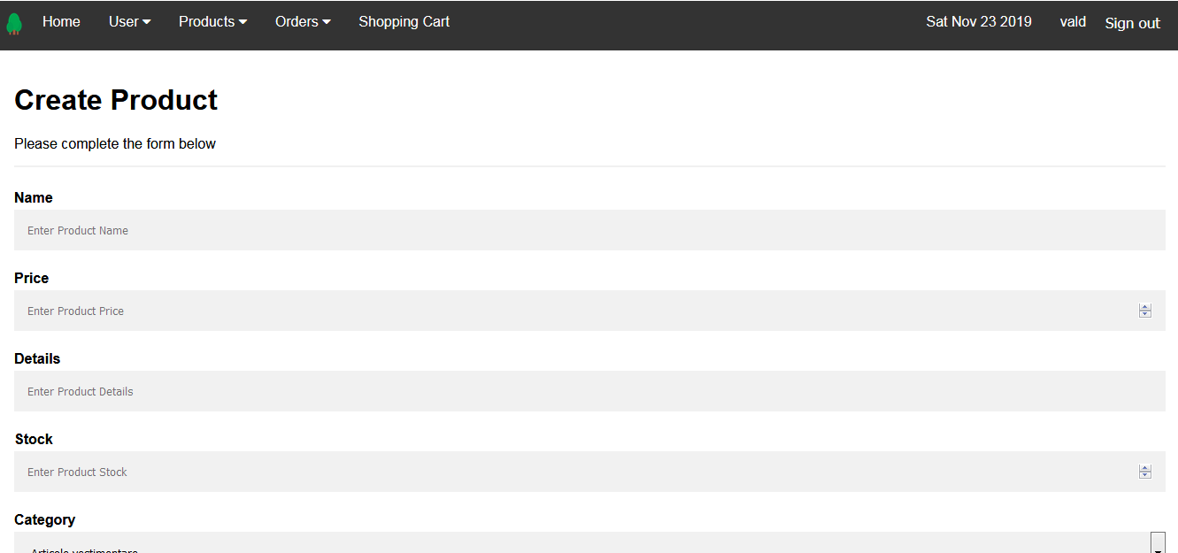

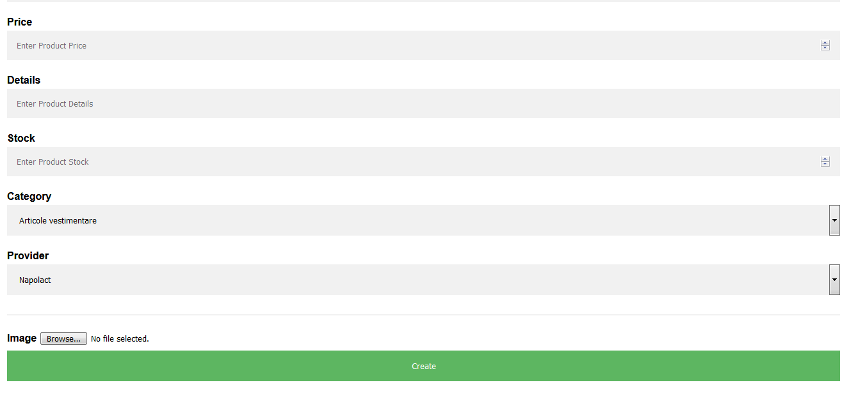

* 1. Create provider

An admin may add a new provider to the database using this page.

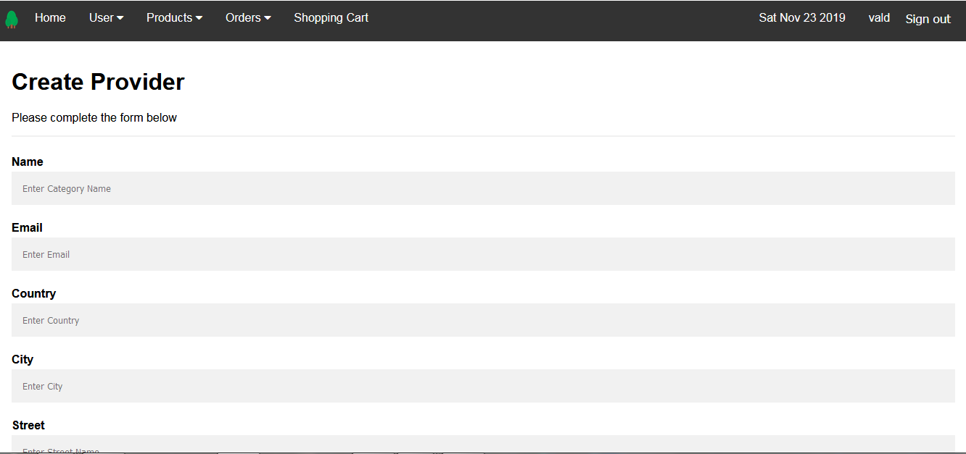

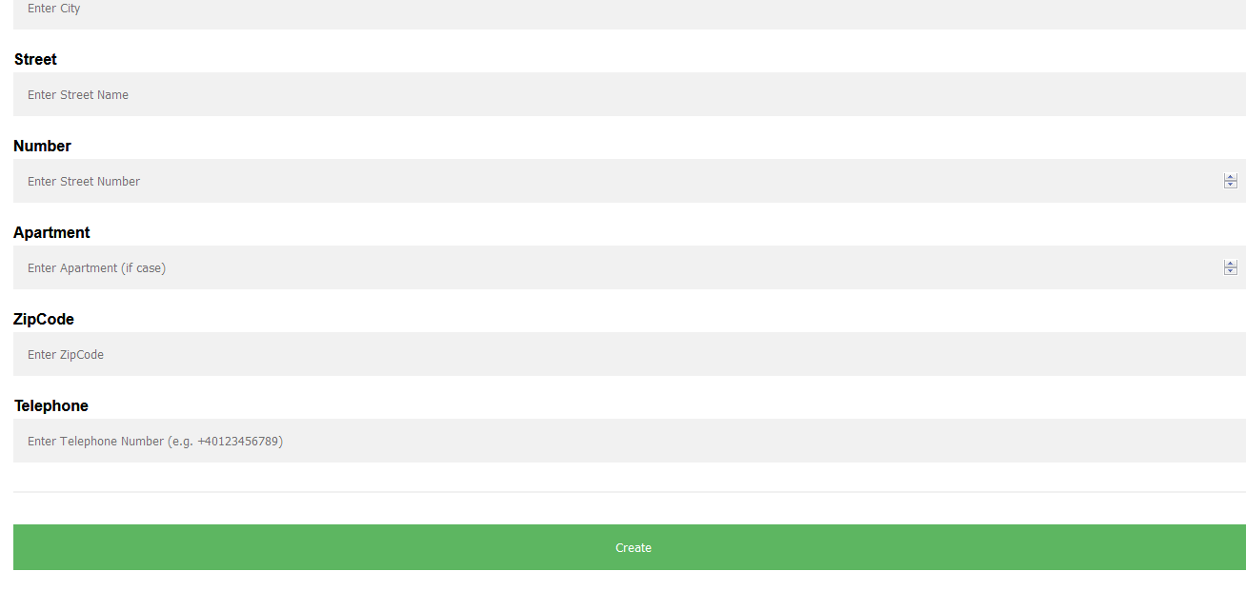

* 1. Inspect Product

The customer can see here the product related details and may choose a quantity and add it to the cart, if desired.

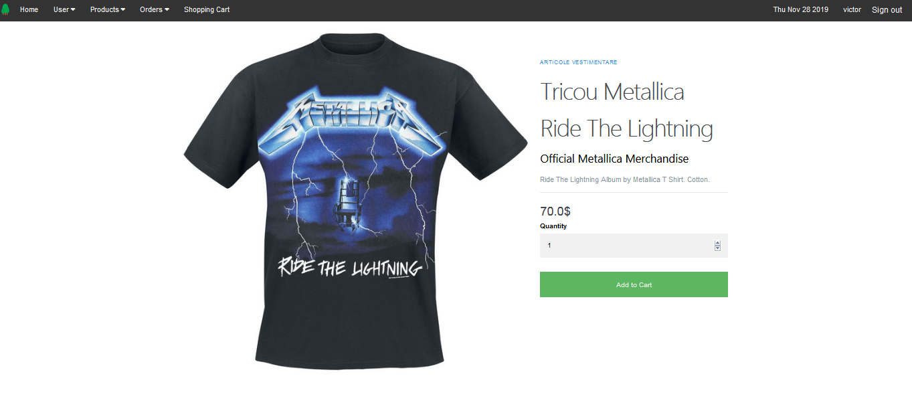

* 1. Cancel Order

A user may request an order’s cancellation, then it needs to be accepted by the admin.

* 1. Courier Orders

The courier may see all the orders they have in this table.

* 1. Search Product

The customer may search a product they are interested in.

* 1. Shopping Cart

Here, a customer can discard or update the quantity for a product and do the checkout.

1. **User Manual**
   1. **Installation**

The project is not meant to be installed or even exist on the end consumer’s machine, as it should be hosted in the cloud. Yet, if needed (for debugging purposes, for example), the application can be run from a coding environment, from a computer containing all the source files, MongoDB, Java and Maven. Alternatively, it can be run using the .jar file.

The project was dokerized in two different containers, but it wasn’t uploaded to the cloud.

* 1. **Operation**

By logging in, the user can access the pages relevant to their type (admin, customer or courier). The menu accompanies them on each page and holds links to all the pages. Another important part is the Actions column, present in the interactive tables. It contains links to corresponding pages.

* 1. **Site Maps**

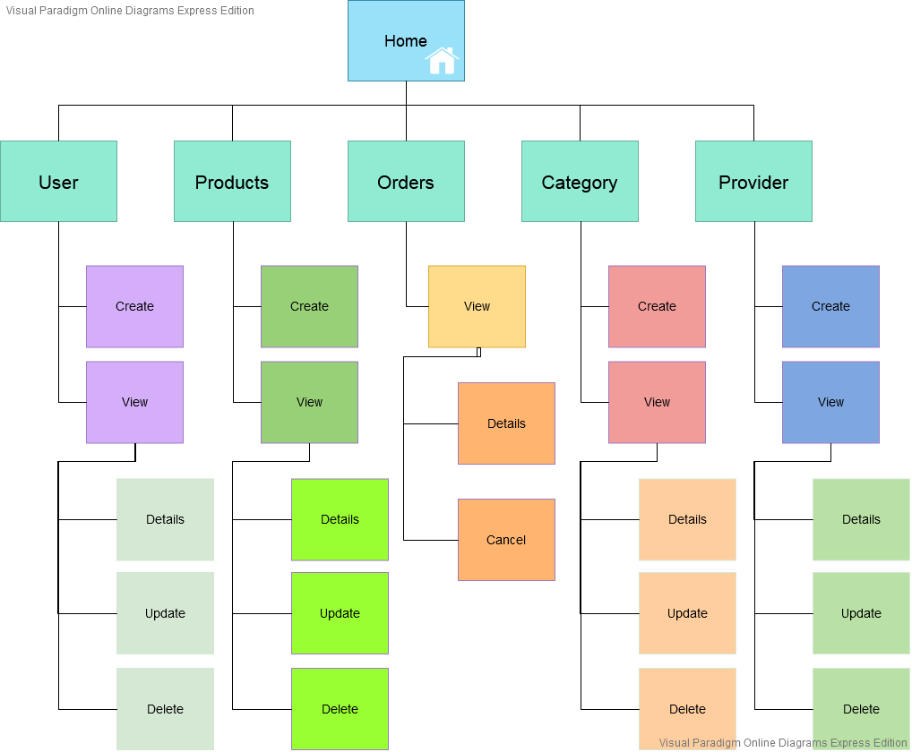

Admin Site Map

Courier Site Map

1. **Portability**

This software may be used on any machine that has JDK, JRE, Maven and MongoDB installed. Even better, by building a JAR file, it would contain all its necessary dependencies, classes and resources and run it, only needing a JRE and MongoDB.

Further, the application could be dockerized. The persistence should be kept separately in order to keep the data between runs. For demonstrative purposes only, the database could be dokerized too.

1. **Competing software**

There is a large number of e-commerce websites, that sell and deliver products, already present, such as:

* **Amazon**
* **emag**
* **eBay**
* **Alibaba**
* **olx**

and many others.

1. **Testing and Validation**
   1. **Test Cases**

* Register

The user selects the register button and is redirected to the Register Page. They should complete the registration form. After hitting the register button, if erroneous data is present, the user should be notified, else, they are registered and redirected to the home page.

* Login

The user selects the sign-in button and is redirected to the login page. If the credentials they enter are correct, they are redirected to the main page, else, they are notified.

* Browse products and add product to cart

The user enters the browse product page and they can see all the active products. They select the product they are interested in, hitting the Details button. They are redirected to the Product Description page, where they may see all de details about the product. They select the desired quantity and hit the Add To Shopping Cart button. They are redirected to the shopping cart.

* Search Product

The user enters the search product page and enters the name of the desired product. Several products containing the entered name are listed.

* Update Shopping Cart Quantity

The user is at the shopping cart and tries to update the quantity of a product. They change the complete the quantity field with the desired one and hit the “Update” button. The available stock and the quantity should be changed accordingly.

* Search by Category

The user enters the search by category page and selects the name of the desired category. All the products in that category are listed.

* Search by Provider

The user enters the search by category page and selects the name of the desired provider. All the products with the selected provider are listed.

* Checkout

The user is at the shopping cart page and proceed to checkout. They are prompted a checkout form. They do not complete the address form and press the checkout button. The order is placed with the address present in the customer’s profile.

* Checkout Custom Address

The user is at the shopping cart page and proceed to checkout. They are prompted a checkout form. They complete the address form and press the checkout button. The order is placed with the provided address.

* Update User Details - Customer

The customer enters the update page. They change their details accordingly (even password), then proceed to confirmation. As a result, their details are updated in the database. At the next login, their password should be the new one.

* Create Customer - Admin

The admin is at the create user page and complete the form accordingly, with the user status selected as customer. If erroneous data was introduced, an error will appear. A new user entity is inserted in the database with the customer status.

* Create Provider

This can be done by the admin only. They enter the create provider page and complete the form. If erroneous data is inserted, the user is notified, else, after the create button is hit, a new provider will be added to the database.

* Create Category

This can be done by the admin only. They enter the create category page and complete the form. After the create button is hit, a new category will be added to the database.

* Create Product

This can be done by the admin only. They enter the create product page and fill in the requested details. After clicking “create”, the new product will be added to the database.

* Delete Product

This can be done by the admin only. The admin is at the page listing all the product and selects the delete action. They will be prompted with the details of the product and asked to click the delete button again. After that, the product will still be in the database, with the deleted status.

* Update Provider

This can be done by the admin only. They enter the update provider page, which can be accessed through the “Update” action link inside the table with all the providers, and complete the form. If erroneous data is inserted, the user is notified, else, after the update button is hit, the provider will be updated in the database.

* Complete Order

This can be done by the courier only. They select the “Complete Order” action button inside the table listing all their corresponding orders. They will be prompted a confirmation form. If they hit the complete button, the order’s status will be updated in the database.

* 1. **Bug List**

Mid-development

|  |  |  |  |  |
| --- | --- | --- | --- | --- |
| Bug | Test Scenario | State | Bug Correction | Bug Verification |
| Deleted products listed | Browse products and add product to cart | 2 | Victor Padurean | Victor Padurean |
| Cannot login after user update | Update User Details - Customer | 0 |  |  |
| Negative quantity | Browse products and add product to cart | 3 | Victor Padurean | Victor Padurean |
| Quantity greater than stock | Browse products and add product to cart | 3 | Victor Padurean | Victor Padurean |
| Search doesn’t work | Search Product | 1 | Victor Padurean | Victor Padurean |
| Stock isn’t updated | Update Shopping Cart Quantity | 0 |  |  |

Final

|  |  |  |  |  |
| --- | --- | --- | --- | --- |
| Bug | Test Scenario | State | Bug Correction | Bug Verification |
| Deleted products listed | Browse products and add product to cart | 3 | Victor Padurean | Victor Padurean |
| Cannot login after user update | Update User Details - Customer | 3 | Victor Padurean | Victor Padurean |
| Negative quantity | Browse products and add product to cart | 3 | Victor Padurean | Victor Padurean |
| Quantity greater than stock | Browse products and add product to cart | 3 | Victor Padurean | Victor Padurean |
| Search doesn’t work | Search Product | 3 | Victor Padurean | Victor Padurean |
| Stock isn’t updated | Update Shopping Cart Quantity | 3 | Victor Padurean | Victor Padurean |